Implementation of Image Segmentation

Prepared by
Aimee Valladares

Computer Vision
CAP 4410
18 October 2020
Table of Contents
Table of Contents 1
List of Figures 2
List of Equations? 6
1. Image Segmentation 7
1.1 Introduction 7
1.2 Project Description 7
1.3 Program Design 8
2. OpenCV Project 10
2.1 Program Code 10
2.2 Test Plan 10
2.3 Test Results 10
2.4 Conclusion 11
References 12

List of Figures
Figure 1 Types of segmentation ..………………………………………………………….................... 2
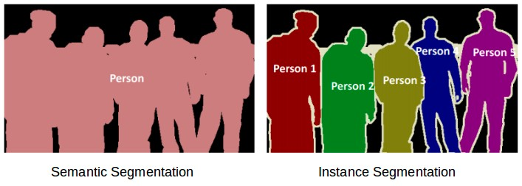

Figure 2 Otsu-binarization Multi-thresholding ....................................................................................... 3
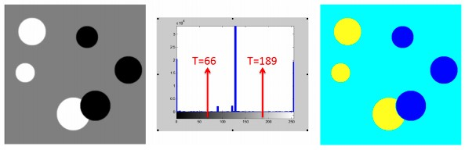

Figure 3 OTSU 2 Class Implementation Input Image …………………………………….................... 10


Figure 4 OTSU 2 Class Implementation Modified Image ………..……………………….................... 11
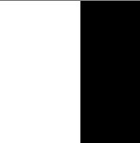

Figure 5 OTSU Multiple Class Implementation First Image ………………………….….................... 11
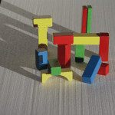

Figure 6 OTSU Multiple Class Implementation First Image – Modified ...……………….................... 11
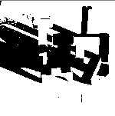

Figure 7 OTSU Multiple Class Implementation Second Image ………...……………….................... 11
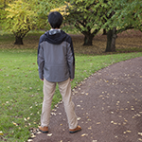

Figure 8 OTSU Multiple Class Implementation Second Image – Modified ......……….................... 11
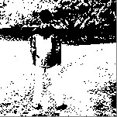

Figure 9 Mean Shift Implementation First Image …………………....………………....................... 11
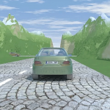

Figure 10 Mean Shift Implementation First Image – Modified ……....……………….................... 11
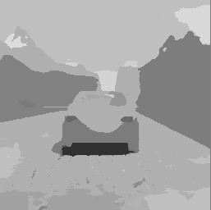

Figure 11 Mean Shift Implementation Second Image ……..……....………………......................... 11
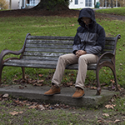

Figure 12 Mean Shift Implementation Second Image – Modified …....………………...................... 11
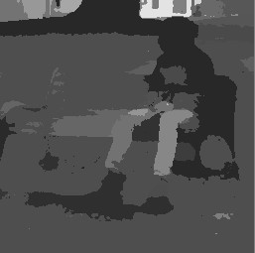

List of Equations
Equation 1 Image Binarization ...….…………………………………………………….................... 7
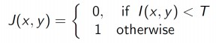
Equation 2 Otsu-binarization ............................................................................................................... 7
variance of pixels p with I(p) ≤ u
variance of pixels p with I(p) > u
Probability of each class for threshold u

Equation 3 Mean Shift ………............................................................................................................. 7
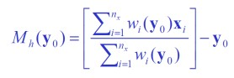
n_{x}: number of points in the kernel
y₀: initial mean location
x_{i}: data points
h: kernel radius

Equation 4 Probability Density Function …........................................................................................ 9
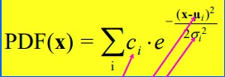
* The arrows reflect the certain initial variables are estimates

Equation 5 Kernel Density Estimation – Epanechnikov Kernel .......................................................... 9
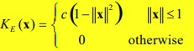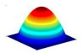

Equation 6 Kernel Density Estimation – Uniform Kernel ..…………………………….................... 9
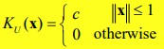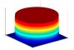

Equation 7 Kernel Density Estimation – Normal Kernel ..……………………………...................... 9
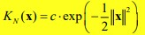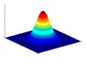

Image Segmentation

Introduction
Image segmentation is the process of partitioning an image into regions, called segments. The segments are essentially sub-images that capture meaningful objects (that shares a similar property) in the input image [1]. Several image segmentation techniques can be broadly categorized into two types: Semantic segmentation and Instance segmentation. Semantic segmentation will categorize every pixel to a particular class either the foreground or background and have the class represented by the same color. Whereas instance segmentation will assign a particular class to each image pixel but categorize the different objects with the same class with different colors. This is two segmentation types are illustrated in Figure 1 [2].

There are different approaches toward image segmentation that involve a variety of different methods. For instance, simple image binarization is a method that utilizes the global threshold to determine the segments, as seen in Equation 1. This method alone can be applied differently due to it having multiple operations. Another method toward image segmentation is a region growing method that utilizes seed pixels that recursively adds adjacent pixels until all pixels are in segments. Finally, another method toward segmentation is split and merge. This method splits the image into four quadrants and further split in each quadrant until it can no longer occur. Then merge the regions that have the “similarity criterion” until further merges are possible [1].

Project Description
In this project we are focusing on the implementation of certain semantic segmentation methods on the given input images. The image segmentation methods that will be utilized are Otsu-binarization and mean shift segmentation.

Otsu-binarization is a thresholding segmentation method which can be seen in Equation 2. This method calculates and reads the input image’s histogram to understand the pixel distribution and intensities in the image. Then the method calculates the threshold value so the overlap between classes is reduced. The Otsu-binarization method can apply simple thresholding that assumes the input image is a bi-modal image which contains two classes of pixels. One pixel class is designated as the foreground with contains the objects and another pixel class is designated as the background which contains all the other pixels. However, the Otsu-binarization method can employ multi-thresholding that results in multiple classes that creates more segments within the image [1].

Mean shift segmentation is a region-based segmentation method which can be seen in Equation 3. This method locates the regions in with the largest density in the image by shifting the region of interest towards the center of mass. This shifting is done with a mean shift vector that takes the image data points and initial mean to estimate the exact location of the mean of the data. The mean shift vector has the direction of the gradient of the density estimate. The mean shift additionally can utilize different kernel density estimations that affects the underlying probability density function’s (PDF) shapes. The parametric density estimation is used to demonstrate the density of the data points in a 3D model [3].

The main objective of this project is to utilize the different approaches to image segmentation and how each method partitions the image. This implementation will be done by creating an OpenCV project that will demonstrate the how different image segmentation methodologies will affect how the segments from the image will be formed.

Program Design
The OpenCV project in Visual Studio will comprise of several C++ files that will each implement a specific image segmentation method through different means. The OpenCV code will comprise of four C++ files and a header file with each file using different classes. The first program is comprised of one file. This program will apply the Otsu-binarization method and implement with two classes. First the file will utilize the necessary files in the OpenCV library and include the necessary routines to run the program. The file will then read and load the input image through its file path. Then an if statement is used to check and avoid any possible errors and failures the program may have when running the program. Specifically, check if the input image is read and inputted correctly. Then the program will call upon the two classes: The Conversion class and the Thresholding class. The Conversion class will take the input image and convert into a gray-level image. The Thresholding class will then take that gray-level image and apply one global threshold to it, essentially creating a binary image. The global threshold is calculated from the image histogram data. The file will then display the original input image and the segmented image [4] [5].

The second program is comprised of one file. This program will also apply the Otsu-binarization method though this program will implement multiple classes. This file is similar to the previous file but contains one significant difference. Though this file also utilizes the Otsu segmentation method, this file will apply multiple thresholds. Applying multiple thresholds will allow the program to identify multiple objects in the image that are partitioned into different segments. For instance, as shown in figure 2, the program will identify the different sets of objects and segment them accordingly. Like the previous file, the program will read and load the image as well as run a conditional statement to ensure that the program will run properly. The file will then call upon four classes: the Conversion class, the Edge class, the Thresholding1 class, and the Thresholding2 class. The Conversion class will take the input image and convert into a gray-level image as well as apply the Sobel edge detector and Gaussian filter. The Edge class will take the gray-level image and apply the Sobel edge detector to help distinguish the edges of the object classes. The Thresholding1 class will then take that gray-level input image and calculate one of the threshold values from the input image’s histogram data. The Thresholding2 class will also take the gray-level input image and calculate the second threshold value from the input image’s histogram data. Then the program will take those two threshold values and apply it to the input image to segment multiple object classes. This will create a new image that will partition multiple object classes in the image.

The third and final program is comprised of 3 files: one header file and two C++ files. The header is used to declare and define the variables and processes that will be used by the implementation and main files. One of the C++ files is used to implement the mean shift segmentation. In this file, the program simulates the mean shift by having the program locate the modes (the value that appears most often in the data), which reflect the density in the image, to determine the underlying probability density function as seen in Equation 4. The program also takes into account the Kernel Density Estimation as seen in Equations 5-7. Specifically, the program utilizes and implements the Uniform Kernel conditions. Additionally, this file also tries to handle more complex functions and scenarios. Specifically, the program tries to resolve the saddle point scenario. The program does this by pruning the modes by perturbing them which finds any saddle points or plateaus and then prunes the points nearby and takes the largest mode within that window. Furthermore, this program tries to adhere and address important properties and characteristics the mean shift demonstrates. Notable examples include addressing the number of convergence steps may occur for the uniform kernel and the adaptive gradient ascent for the speed and size steps occur. Finally, the second C++ file is used to call upon the implementation C++ file and print out the resulting images [6] [8].

OpenCV Project

Program Code
The OpenCV Project was written in C++ with Visual Studio with the project consisting of five total files. The program source code can be seen on separate files within the .zip folder provided. The files are well-commented, with extended comments being used to help explain the logic of the code [5] [6] [7] [8] [9] [10].

Test Plan
To properly demonstrate the performance and accuracy of the OpenCV project code, we run each of the programs and analyze the outputs. To analyze how accurate the program is we compare the modified image with the original unedited input image with the input image acting as the control. For this project we will focus on how the program partitioned the image into segments based on each approach.

Each of the programs will generate two images in separated windows. The first generated window will display the original unedited image. The second generated window will display the original image being modified by the segmentation method.

The first program will generate two images: the original image and the modified image. Due to the program implementing the simple Otsu-binarization thresholding method, the modified image is essentially a binary image. This method should modify the image to display the foreground and background.

The second program will generate two images: the original image and the modified image. Due to the program implementing the Otsu-binarization multi-thresholding method, the modified image is essentially a gray-level. This method should modify the image to display multiple object classes in the image.

The third program will generate two images: the original image and the modified image. Due to the program implementing the Mean Shift implementation method, the modified image is essentially gray-level image with smoother edges due to the program utilizing a smoothing filter.

Test Results
The OpenCV project was able to perform correctly though the accuracy of each program implementation varies from program to program (within a margin of error) in depicting the implementation of the specified image segmentation methods. This is illustrated by the images seen between Figures 3 - 12.

Figures 3 and 4 depicts the results of the first program implementing the Otsu-binarization method with two classes. When comparing the original image seen in Figure 3 with Figure 4, the program did illustrate the segmentation with the Otsu-binarization with great accuracy as the image modifies the image to assign one object in the image into the foreground and assigned all other pixel values in the image into the background.

Figures 5 – 8 depicts the results of the second program implementing the Otsu multi-thresholding method with multiple classes. When comparing the original images (Figures 5 and 7) with the resulting output images (Figures 6 and 8), the program did illustrate segmentation while utilizing the Otsu method and displayed clear silhouettes due to the Sobel edge detector. However, the image did not really distinguish the multiple objects in the image.

Figures 9 – 12 depicts the results of the third program implementing the mean shift method. When comparing the original images (Figures 9 and 11) with the resulting output images (Figures 10 and 12), the program illustrated the mean shift segmentation with great accuracy as the image clearly partitioned the image into different segments due to assigning each segment having a different gray-levels.

Conclusion
Image segmentation is an important concept of image processing due to its countless applications. Image segmentation used to identify regions that are occupied by the objects in the image. Image segmentation has many applications like image facial recognition, augmented reality, and object detection and tracking. In this project, we learned how different approaches and methods towards image segmentation can lead to different results. The most accurate implemented method being the mean shift method as it clearly partitioned and distinguished between each segment in the image.

One improvement I would make to the project is to have the Otsu-binarization program with multiple implementation classes to apply the different threshold values on the image with greater accuracy. One approach to this improvement could be done by having the program call upon three classes that focus on different values. One class would distinguish what pixels are the background. Another class would determine the pixels that distinguish the edges possibly with a Canny Edge detector filter. Finally, the third class would focus on the brighter pixels in the image that denote the objects in the image. This would have made the different object classes in the image more distinct [las]. Another improvement I would make to the project is to possibly make the programs more user friendly by allowing the user to input an image with a generated window.

References

[1] Abid, Muhammad, Lecture 8 Slides, CANVAS Concise Computer Vision
[2] Pulkit SharmaMy research interests lies in the field of Machine Learning and Deep Learning. Possess an enthusiasm for learning new skills and technologies. “Image Segmentation: Types Of Image Segmentation.” Analytics Vidhya, 11 May 2020, www.analyticsvidhya.com/blog/2019/04/introduction-image-segmentation-techniques-python/.
[3] Abid, Muhammad, Lecture 8 Slides, CANVAS Concise Computer Vision
[4] “Basic Thresholding Operations.” OpenCV,n docs.opencv.org/3.4/db/d8e/tutorial_threshold.html.
[5] “Image Thresholding.” OpenCV, docs.opencv.org/3.4/d7/dd0/tutorial_js_thresholding.html.
[6] Datahacker.rs. “OpenCV #007 Thresholding.” Master Data Science, Datahacker, 26 Oct. 2019, datahacker.rs/opencv-thresholding/.
[7] “Color Space Conversions.” OpenCV, docs.opencv.org/3.4/d8/d01/group__imgproc__color__conversions.html.
[8] Comaniciu, Dorin, and Peter Meer. Mean Shift: A Robust Approach Toward Feature Space Analysis. IEEE, May 2002, courses.csail.mit.edu/6.869/handouts/PAMIMeanshift.pdf. IEEE Transactions on Patter Analysis and Machine Intelligence, VOL. 24, NO.5
[9] Bbbbyang. “Mean Shift Segmentation.” GitHub, github.com/bbbbyang/Mean-Shift-Segmentation.
[10] “C++ Classes and Objects.” GeeksforGeeks, 8 Nov. 2019, www.geeksforgeeks.org/c-classes-and-objects/.
[11] “Multi Otsu Threshold.” ImageJ, imagej.net/Multi_Otsu_Threshold.

